https://www.ncbi.nlm.nih.gov/books/NBK343489/

The Role of Lipids and Lipoproteins in Atherosclerosis
MacRae F Linton, MD, Patricia G Yancey, PhD, Sean S Davies, PhD, W. Gray Jerome, PhD, Edward F Linton, MD, Wenliang L Song, MD, Amanda C Doran, PhD, MD, and Kasey C Vickers, PhD.
- Created: January 3, 2019. www.endotext.org

Levels of LDL-C, ApoB-100, Non-HDL Cholesterol and LDL-P as Markers for ASCVD Risk.
Based on the strength of the direct association of LDL-C levels and risk for ASCVD, the guidelines for treatment of hypercholesterolemia have focused on LDL-C levels for risk assessment, stratification and treatment recommendations. Indeed, the terms LDL-C and LDL are often, though incorrectly, used interchangeably in practice. It is important to understand that LDL is a collection of particles defined by density (d = 1.019 – 1.063 g/ml) that are heterogeneous, consisting of a large variety of lipids and proteins (459). In addition, LDL particles vary in size and cholesterol content. The relationship between LDL-C levels and risk for ASCVD is “J-shaped”, and the predictive value of LDL-C levels is better at higher levels of LDL-C. Surprisingly, the majority of subjects presenting to the hospital with acute coronary artery syndrome do not have elevated levels of LDL-C, but tend to have low levels of HDL-C and elevated triglycerides (460). There has been tremendous interest in whether other measures of LDL, including subpopulations, apoB100, or particle number, might serve as a better predictors of CVE than quantifying LDL cholesterol content.
Groundbreaking studies by Krauss and co-workers (461) described two major patterns for LDL subpopulations based on size and density of the LDL particles. Pattern A is characterized by large buoyant LDL (lbLDL) particles, whereas Pattern B is associated with small dense LDL (sdLDL). Importantly, sdLDL is associated with increased triglyceride levels and low HDL-C, which is referred to as the lipid triad, a phenotype common in insulin resistance. Hence, Pattern B is commonly seen in subjects with obesity, metabolic syndrome and type 2 diabetes mellitus. A number of studies have reported that Pattern B is associated with an increased risk of CVE (462). Several different approaches have been used to characterize LDL phenotypes, including gradient gel electrophoresis, ultracentrifugation (sequential and vertical), ion mobility and nuclear magnetic resonance (NMR) (462,463). A number of mechanisms have been proposed to underlie the proatherogenic properties of sdLDL, including increased susceptibility of oxidation (464) and glycation (465), promoting arterial retention and increased macrophage foam cell formation. Cholesteryl ester transfer protein (CETP), which transfers CE from HDL to VLDL/LDL and triglycerides in the opposite direction, and hepatic lipase, which hydrolyses triglycerides, impacts the lipid composition and size of sdLDL. As such, increased levels of sdLDL have the potential to provide additional information regarding risk of CVE in individuals with normal LDL-C levels but elevated triglycerides and low HDL. Alternatively, it has been proposed that the real impact of sdLDL is due to increased LDL particle number.
Each LDL particle contains one molecule of apoB100, and the majority of apoB100 in plasma is on LDL particles (466). Hence, levels of apoB100 correlate directly with LDL particle (LDL-P) number. A large number of studies have shown that levels of apoB100 are superior markers of ASCVD risk compared to LDL-C (467). Because the mass of cholesterol in LDL particles varies, LDL-C levels will result in overestimation apoB levels and the number of LDL particles, when LDL particles are cholesterol-enriched (Figure 8) and underestimate apoB and LDL particle number when the particles are cholesterol depleted (Figure 8)(468).
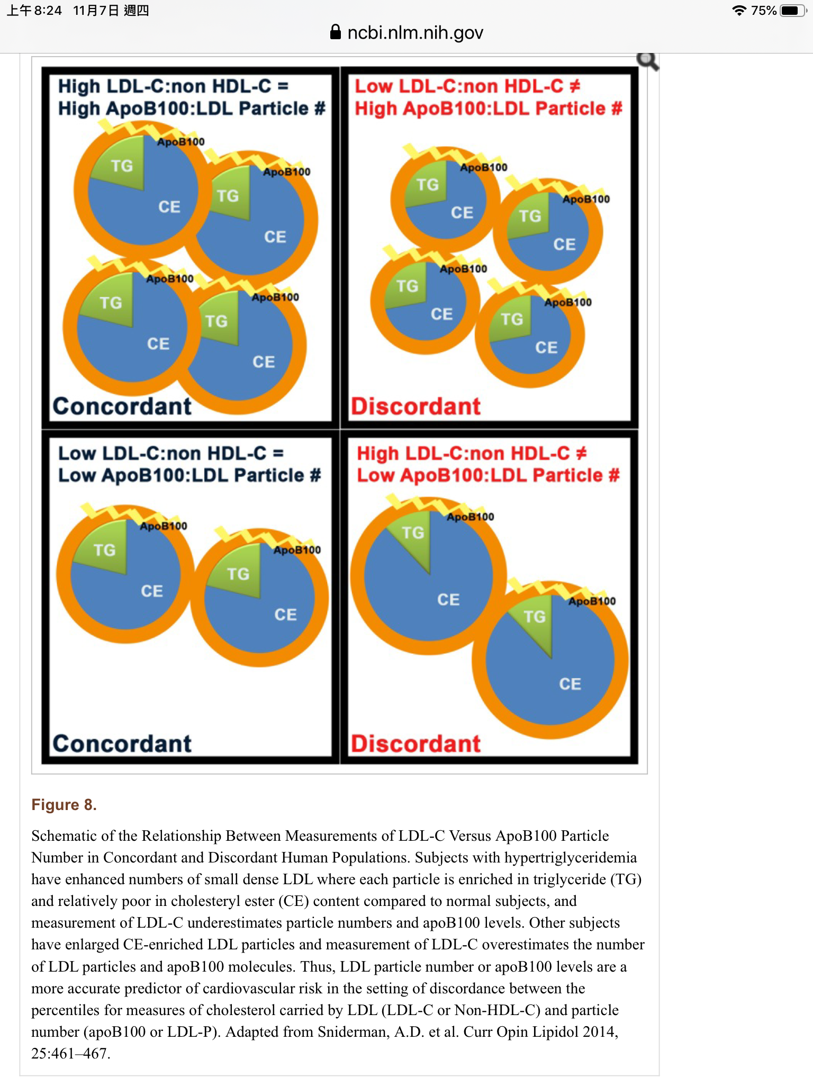
Furthermore, all of the major atherogenic lipoproteins contain apoB (LDL, triglyceride rich remnants of VLDL, IDL, chylomicron remnants, and Lp(a)). LDL-C is routinely calculated using the Friedewald formula (LDL-C = TC – HDL-C – TG/5), but this formula is not accurate when serum TG levels are > 400 mg/dl. It has long been recognized that LDL-C underestimates risk of ASCVD in the setting of hypertriglyceridemia (467). Non-HDL cholesterol is the mass of cholesterol in all of the apoB-containing particles: Non-HDL-C = TC – HDL-C. The ATPIII guidelines recommended using Non-HDL-C to estimate risk of ASCVD, when TG > 200 mg/dL (469,470). A meta-analysis by Sniderman et al. found that Non-HDL-C was a slightly better marker of ASCVD risk than LDL-C, but apoB was far superior to Non-HDL-C (471). NMR spectroscopy is another way to measure LDL-P concentrations. Table 2 includes selected percentiles for mean levels for the various LDL-related markers from the Framingham Offspring Study (472). In an analysis of the Framingham Offspring Study, LDL-P determined by NMR was more strongly related to incident CVD events than LDL-C levels, and the ability of Non-HDL-C to predict risk was less than LDL-P, but better than LDL-C (473). In addition, they found that low LDL-P numbers were a better index of low CVD risk than low LDL-C (473). In contrast, an earlier meta-analysis from the Emerging Risk Factors Collaboration found LDL-C, Non-HDL and apoB to be equivalent markers of CVE (474). The lack of difference may relate to the population studied. When the LDL particles have normal cholesterol content, then LDL-C, Non-HDL and apoB are equivalent markers (Figure 8) of risk (471,473). Interestingly, data from the Multi-Ethnic Study of Atherosclerosis (MESA) demonstrated that when LDL-C and LDL-P are discordant (Figure 8), then LDL-P proves to be a better predictor of risk for incident CVD events than LDL-C (475).

