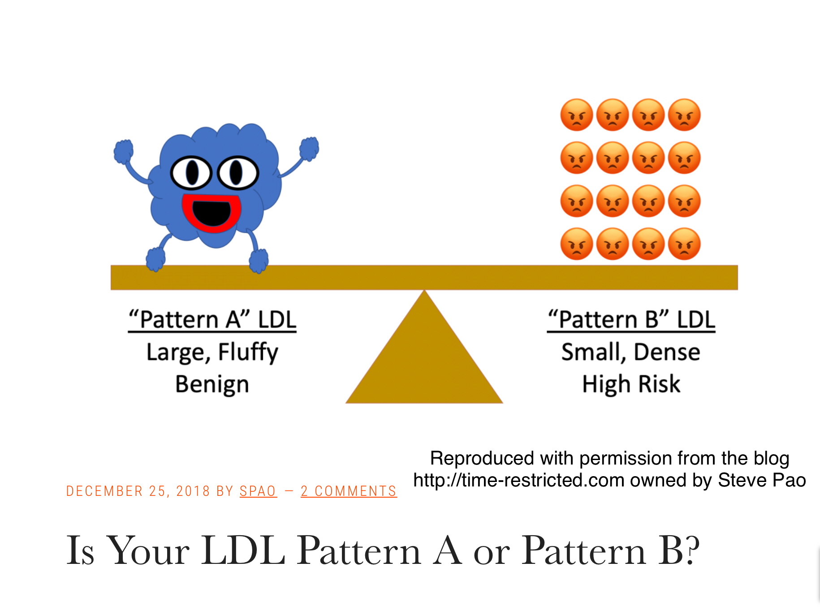

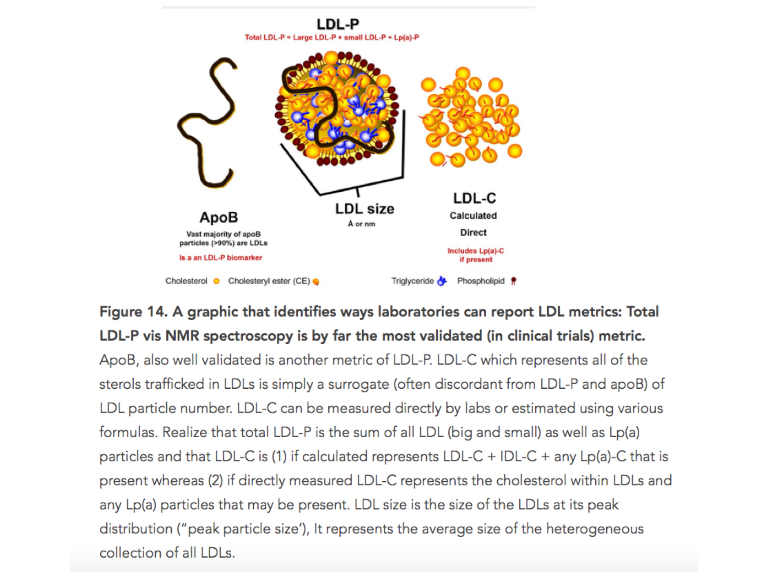
Source of Fig 14: Interview with Thomas Dayspring, MD, FACP (Peter Attia Drive)

